**Jurnal sains nuklear malaysia (JSNM)**

**(*Nuclear Science Journal of Malaysia*)**

**Peer Review Policy**

Peer review ensures that only original, high-quality, impactful scientific articles are published.  Our referees play a vital role in upholding the JSNM's high standards.  All manuscripts submitted are editorial using the procedures stated below.

**Initial manuscript evaluation**

The management editorial staff initially screens manuscripts for plagiarism, completeness, and conformity to the journal's official standards. Manuscripts can be returned to authors for corrections within 5 days of receipt before being delivered to the Chief Editor’s desk.

The Chief Editor (CE) assesses all submitted papers within 5 days after receipt at the CE desk. The CE determines whether they are appropriate for review progression based on their relevance to the journal's scope, publication standards, and interest in the policy community. Those that meet the requirements will assigned to the editorial board member for review. Manuscripts rejected at this stage are either outside the journal's aim and scope, have significant scientific faults, or have poor grammar or English language. The authors of manuscripts that are rejected at this stage will usually notified within 10 days of receipt.

**Type of peer review**

The JSNM employs ‘double-blind’ reviewing, in which the referees remain anonymous to the author(s) throughout and after the refereeing process, and the reviewers are likewise unaware of the author(s) identity.

**How the referee is selected**

For the review of the manuscript, the CE will designate at least two experienced editors/ reviewers who will be matched to the paper content based on their academic expertise. The JSNM typically completes the first phase of the refereeing procedure within 21 days.The nominated editors/ reviewers have 7 days to confirm their willingness to conduct the review within that timeframe.

Editors or reviewers may advise improvements to the manuscript's English language and style. The manuscript may return to the authors for extensive linguistic and stylistic revisions.

**Final report**

Upon completion of the review, a revised manuscript will be sent to the CE within 5 days.  If a revision is needed, the author will given 14 days.  The CE will take 3 days to access the revision report. If necessary the revision report will be sent to the reviewer for a final assessment in 5 days.  The CE decision to accept or reject the manuscript will be sent to the author within 3 days, along with the recommendations made by the CE/ reviewers.

**The Chief Editor decision is final**

The CE ultimately decides on whether to accept or reject the article.

**Communications with authors**

Authors will receive reasoned and constructive comments on their manuscript's decisions during the review period.

**Competing interest**

The reviewers should contact the CE for any conflicts with the assigned manuscript, such as profitable, collaborative, or other relationships with the authors, companies, or institutions. In such cases, they should notify the CE and withdraw from the review process.

**Confidentiality**

Manuscripts received for review must treated as confidential documents. Participants in the review process are kept anonymous.

**Author copyright and license agreement**

CE will send an email to the author with any essential points on copyright transfer and agreement concerns after the article has been peer-reviewed, accepted, and moved into production.

The production manager will notify the author of the manuscript's confirmation for publication. The production procedure takes around (22 days) before the publishing date.

The following is a flowchart of the manuscript review process.

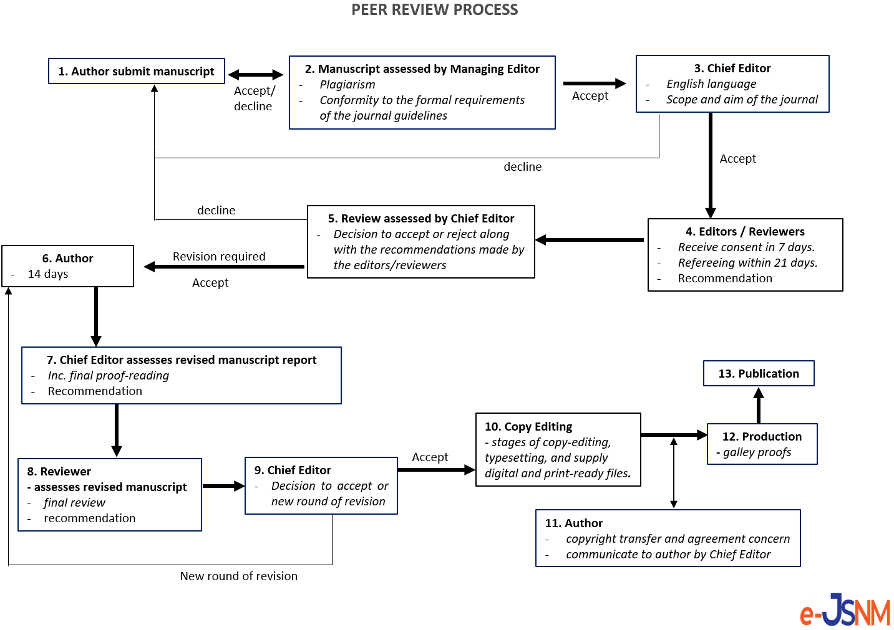

Figure1. Flowchart of the peer review process